NATIONAL REPORT ON ECOLOGY & CLIMATE ISSUES IN PRIMARY SCHOOL ENGLISH LANGUAGE TEACHING CURRICULA

📅 Reporting Period: [17/03/2025-25/03/2025]

✍️ Prepared by: [Res. Asst. Özlem Demir, Balıkesir University]

📍 Country: Turkey

Introduction

This report aims to analyze to what degree and how the topics of ecology, climate change, and environmental sustainability are addressed in the English Language Teaching Program published by the Turkish Ministry of National Education (MEB) in 2018. The report examines the respective units and skill outcomes at the level of primary schools (grades 2-4). It also considers the use of supporting materials such as booklets, flashcards, and interactive exercises that can help students' understanding of these issues and make them more interested in the subject matter.

A short overview of the education system regarding English language teaching in Turkey

Turkey's education system underwent a radical transformation from the 8+4 to the 4+4+4 system, which was legislated in 2012 and impacts primary and secondary education. Under the new system, children begin education at age 6, and the system is divided into three stages: Primary Education (Grades 1–4), Secondary Education (Grades 5–8), and High School (Grades 9–12).

One of the most significant aspects of this transition has been the redesign of the English language curriculum. In the pre-4+4+4 system, English education began at the 4th grade, but with the new system, English education starts from the 2nd grade. This necessitated the development of a new curriculum that would be appropriate for younger learners while being pedagogically sound and remaining aligned with international standards.

The new curriculum in English is interested in both language proficiency and communication ability, with speaking and listening being prioritized at the early years of schooling (grade 2 and 3) and introducing reading and writing skills gradually at upper grades. Such a shift is in keeping with the Common European Framework of Reference for Languages (CEFR), which stresses the importance of actual communication and communicative competence (CoE, 2001). The CEFR underpins the design of the curriculum, which takes an eclectic mix of approaches to teaching, allowing room for accommodating a variety of learner needs and learning styles.

The new curriculum is intended to establish a positive classroom environment, with an emphasis on real materials, drama, role play, and practical tasks. These methods are intended to make the learning of English more engaging and exciting for young learners. By prioritizing learner autonomy and problem-solving, the curriculum aligns with the CEFR's perspective of language learning as a lifelong process.

The revision of the English language curriculum in Turkey, as discussed, emphasizes the importance of developing language proficiency through authentic communicative environments and adaptable instructional methods. While these revisions have set a strong foundation for language learning, there remains a significant opportunity to further enhance the curriculum by integrating broader, cross-curricular themes such as environmental sustainability.

This leads to the focus of the current needs analysis, which aims to explore how environmental sustainability is currently addressed within the English language curriculum and to identify the areas where these two critical fields language education and environmental sustainability can be more effectively bridged. By analyzing the curriculum's content and teaching strategies, this needs analysis will provide valuable insights that align with the goals of the **EcoLingua** project. The findings will support the project’s objective of creating data-driven curricula that integrate environmental issues into language teaching while also developing teacher competencies through collaborative international efforts.

NATIONAL CURRICULUM OVERVIEW

Official ELT Curriculum Guidelines and Main Objectives

The English curriculum in Turkey is prepared and implemented by the Ministry of National Education (MEB). The curriculum is aligned with the Common European Framework of Reference for Languages (CEFR) and aims to provide students with listening, speaking, reading, and writing skills (Milli Eğitim Bakanlığı, 2018).

The 2018 English Language Teaching (ELT) curriculum in Turkey places at its core the effectiveness of English language proficiency for economic, political, and social development. The curriculum emphasizes real-life communication and interactive learning, ensuring language learning is contextualized and engaging. The curriculum encourages the use of authentic materials and places a focus on developing practical communication skills rather than grammar only. For young learners, it incorporates play-based activities, as well as encouraging age-appropriate tasks for all learners. The curriculum emphasizes the use of diverse learning strategies and the provision of a positive learning environment** that motivates learners and enables their language proficiency in real-life situations.

Values Education in the Curriculum in Terms of Ecology in Primary School Curricula

Education at all levels must be grounded in both universal and local values that shape individuals and societies. As outlined in Turkey's Basic Law of National Education No. 1739 and supported by UNESCO (1995), values like **friendship**, **justice**, **honesty**, **responsibility**, and **altruism** are critical. The new curriculum emphasizes values education, integrating these key values into the syllabi rather than treating them as separate entities. The curriculum also emphasizes age-appropriate materials, ensuring that teachers and material designers select content that aligns with students' psychological and sociological development.

In addition to these traditional values, **ecology awareness** should be included as a core value, promoting **responsibility** for the environment and encouraging students to adopt sustainable practices. This can be woven into lessons about conservation, climate change, and the importance of protecting natural resources, helping students develop a sense of **responsibility** and **respect** for the planet.

Curriculum Overview: Themes of Ecology, Climate Change and Sustainability

An analysis of Turkey's 2nd, 3rd, and 4th grade English curriculum reveals that while ecology-related themes such as nature, animals, and sustainability are touched upon briefly, they are not fully integrated into the curriculum at these levels.

In the 2nd grade, the curriculum introduces nature-related content through units such as "Animals," "Fruits," and "Pets." While these units are primarily intended for vocabulary building, there are possibilities of dealing with ecological themes such as habitats of animals, endangered species, biodiversity, seasonal fruits, sustainable agricultural practices, and responsible pet keeping. However, the curriculum must go deeper into these issues to be able to build a more solid environmental consciousness among the students.

At 3rd grade level, environmental and nature-related content appears in the "Weather" and "Nature" units, which comprise initial nature words and outdoor activities. Although these units provide a foundation for discussion on weather patterns and natural surroundings, they do not specifically address important environmental topics such as pollution, climate change, or sustainability. Incorporating these topics into the curriculum will enable students to have a greater understanding of the environmental problems we are experiencing.

The 4th grade curriculum includes some ecological concepts in the units "Fun with Science," "Jobs," and "Food and Drinks." However, the most crucial matters of pollution, global warming, preservation of biodiversity, and sustainability practices like recycling and conservation of energy are conspicuous by their absence. More integrated coverage of these, with real-world ecological content, will equip the students better to understand environmental issues and do their part in saving the world.

In conclusion, while the curriculum includes some nature-related content, the integration of environmental themes could be strengthened, especially by introducing sustainability and conservation topics at an earlier age. A more interdisciplinary approach, incorporating these issues into various subjects, would help nurture environmentally conscious and responsible individuals.

ANALYSIS OF TEACHING MATERIALS & TEXTBOOKS

The approved textbooks and supplementary material for use in the 2024-2025 academic year have been prepared by various publishing houses. There are two coursebooks available for 2nd grade: the Student's Book by MEB Publications and the Sunshine English 2 Student's Book by HECCE Publications.

As for supplementary materials, *Adventures of Zury* and the Teacher's Guide are available. These materials are published by MEB Publications. The books' syllabuses are designed thematically, and the units follow the same theme. Additionally, there are booklets and flashcards for each unit published by MEB Publications. The booklets focus solely on receptive skills, specifically listening and speaking. The flashcards contain pictures presented in the units.

For 3rd grade, there are two coursebooks available, published by different publishing houses: the *ENGLISH 3rd Grade Student’s Book* and *English Grade 3* by SDR DİKEY Publications. Additionally, MEB Publications has prepared a booklet for each unit, along with flashcards containing the vocabulary from the units. *Adventures of Zury* and the Teacher's Guide are also available for this grade.

For 4th grade, the *English Grade 4 Student’s Book* is published by SDR DİKEY Publications, while the workbook is published by MEB Publications. Additionally, *Adventures of Zury* includes content aligned with the covered themes, and the Teacher's Guide is also published by MEB Publications. Unit-based thematic booklets and flashcards are available for this grade as well.

*An Overview of Grade 2 English Coursebooks and Materials*

There are two textbooks designed for 2nd grade. The Student's Book by MEB Publications and the *Sunshine English 2* Student's Book by HECCE Publications, both approved by MEB for use. The units are designed in accordance with the 2018 Curriculum and are thematically structured, with the same themes presented in both books. *The Adventures of Zury* is designed both as a workbook and a storybook for storytelling activities. Its units are compatible with the other coursebooks, and it is published by MEB Publishing. It also includes a teacher's guidebook, which provides instructions in the form of lesson plans. In addition, the supplementary resources and additional materials also cover the same themes (See Table 1).

**Table 1.**

Content of the 2nd-grade English Coursebooks

| ***The Student’s Book***  **by HECCE Publications (2024)** | ***The Sunshine English 2***  **by MEB Publications (2024)** |
| --- | --- |
|  |  |

Content of the 2nd-grade English Supplementary Materials

| ***The Adventures of Zury***  **by MEB Publications (2024)** | ***The Adventures of Zury Teacher’s Guid*e MEB Publications (2024)** |
| --- | --- |
|  |  |

In this report, MEB’s and HECCE Publications textbooks were examined using qualitative content analysis in the context of environmental education and education for sustainable development. Content analysis is a qualitative research method for the systematic examination of specific themes, concepts, and words in written texts with the objective of identifying their frequency (Krippendorff, 2018).

In this context, the content of the textbooks and supplementary materials were analyzed by identifying the units that directly include environmental and sustainability themes. Then, within these units, sample texts, dialogues, reading passages, and exercises were analyzed to assess how environmental issues are addressed and whether they encourage thinking related to sustainability. Finally, the analysis focused on how environmental concepts and green vocabulary are used in the language, examining the linguistic depth in terms of sustainability and ecological awareness. The findings are presented in Table 2 below.

**Table 2.**

Analysis of the 2nd-grade Coursebooks

| **Criteria** | **MEB Publications (2024)** | **HECCE Publications (2024)** |
| --- | --- | --- |
| Units/ Themes on Environment and Sustainability | Unit 8: Pets  Unit 9: Fruits  Unit 10: Animals | Unit 8: Pets  Unit 9: Fruits  Unit 10: Animals |
| Sample Texts, Dialogues, Reading Texts | "Lions can run fast," "Penguins can swim" | "Ducks can swim," "Birds can fly" |
| Assignments | Preparing a poster and drawing animals (p. 108)  Preparing picture dictionary (p.112)  Dialogue-based activities involve naming fruits and animals:“Find someone who”. (p.123)  Drawing a fruit basket (p.127)  Preparing animal masks (p.136) | Matching and sorting tasks (e.g., matching fruits or identifying animal habitats) |
| Songs and Chants | Unit 8: Pets song (p.103), cat chant (p.105)  Unit 9: There are no songs or chants.  Unit 10: There are no songs or chants. | Songs like "I am a duck, I can swim" |
| Green Vocabulary Coverage | The units focus primarily on vocabulary memorization, such as pet and fruit names, without incorporating ecological awareness or values related to sustainability and conservation. | The vocabulary in the units is presented in an isolated and memorization-based manner, without establishing a meaningful context to foster ecological awareness. |
| Overall Evaluation | *The Sunshine* *Students' Book* introduces basic nature-related vocabulary and activities that can be adapted to ecological themes like conservation and renewable energy. While it lacks direct focus on environmental issues, teachers can integrate discussions on habitat protection and sustainability. | The "Students' Book" provides the framework for the teaching of ecological subjects in primary school. It is not specifically focused on environmental issues, but the content and exercises within it may be adapted to raise ecological awareness. |

The inclusion of environmental topics in English as a Foreign Language (EFL) textbooks is increasingly a vital component of sustainable education (Cates, 2000). Since textbooks constitute the foundation of learners' knowledge about environmental topics, it is crucial to examine their potential for raising ecological awareness (Tudor, 2001). The study compares two primary school English textbooks, Sunshine English 2 and Students' Book, based on the occurrence of ecological content, environmental themes, and sustainability-promoting tasks.

Both Sunshine English 2 and Students' Book introduce nature-related vocabulary and topics. However, they differ in the incorporation of ecological awareness.The Students' Book includes several units with environmental elements, particularly in lessons on animals (Unit 10), fruits (Unit 9), and pets (Unit 8). While these units introduce simple vocabulary (e.g., “Lions can run fast,” “I have a cat”), they do not touch upon sustainability, endangered species, or conservation as such. In addition, the book employs rich photographs of nature and animals, which could be exploited for ecological lessons but are limited to vocabulary exercises.

The activities in the Students' Book focus on interactive learning through coloring, drawing, and role-playing. Some activities, such as creating a visual dictionary or a poster, might possibly incorporate environmental themes but do not necessarily encourage discussion of sustainability or green practices.

The "Adventures of Zury" textbook, designed for 2nd-grade English learners, presents a more engaging approach to ecological education compared to both "Sunshine English 2" and the "Students' Book." The "Adventures of Zury" also includes interactive learning activities such as crafts, role-playing, and games that promote ecological awareness. Students can engage in activities such as mimicking animal movements or role-playing the effects of pollution on animal habitats. Furthermore, the speaking and listening activities often include ecological environments, such as asking students to consider where fruits are cultivated and how this relates to environmental effect. These activities make the learning process more active and interactive, integrating language learning with ecological awareness.

However, while "Adventures of Zury" offers more overt links between environmental issues and language learning, it too fails to offer an overarching approach to environmental education. Like the other textbooks, it introduces eco-friendly concepts but without further exploration of major environmental issues like climate change or sustainability.

In conclusion, the comparative analysis of "Sunshine English 2," "Students' Book," and "Adventures of Zury" reveals that while all three textbooks cover some ecological problems, there is considerable variation in how these problems are addressed. "Sunshine English 2" introduces basic nature vocabulary without any direct connection to environmental problems. The "Students' Book" provides more space for ecological interaction, though its approach to environmental problems is relatively superficial. "Adventures of Zury" stands out for its interactive, playful approach to ecology-related content, though without serious treatment of fundamental environmental issues. To better serve the aim of environmental education, all three textbooks would benefit from a more integrated and systematic approach to ecological questions.

*An Overview of Grade 3 English Coursebooks and Materials*

There are two main textbooks used for 3rd-grade students: *ENGLISH 3rd Grade STUDENT'S BOOK* by MEB Publications and *English Grade 3* by SDR Publications. Both textbooks are aligned with the 2018 curriculum of the Ministry of National Education. For this grade level, *Adventures of Zury in London* Activity Book by MEB Publishing has also been released, along with a Teachers' Guide. The content of this activity book aligns with the textbooks provided by MEB Publications, ensuring a consistent approach to language learning. The materials in the *Adventures of Zury in London* Activity Book are designed to complement the curriculum and provide additional practice through engaging activities. Similarly, the Teachers' Guide offers detailed instructions, helping educators effectively integrate the book’s content into their lessons while maintaining the same thematic structure as the main textbooks. In addition, booklets and flashcards are available for each unit, further supporting the learning process. (See Table 3).

**Table 3.**

Content of the 3rd-grade English coursebooks

| **SDR Publications** | **MEB Publications (2019)** |
| --- | --- |
|  |  |

Content of the 3rd-grade English Supplementary Materials

| ***The Adventures of Zury in London Activity Book* by MEB Publications** | ***The Adventures of Zury in London Teacher’s Guide* by MEB Publications** |
| --- | --- |
|  |  |

The analysis of the textbooks provided by MEB and SDR Publications for this grade has been conducted using content analysis methodology. Since the textbooks are thematically structured, the units related to ecology and sustainability were first identified. Then, the approach to these topics was examined, including the analysis of sample texts, dialogues, reading texts, and assignments. Due to the primary education level, the presence of songs and chants, as well as their lyrics, was also considered. Additionally, the coverage of green vocabulary was analyzed to assess how effectively the textbooks integrate ecological awareness and sustainability concepts into the curriculum. The same procedure has also been applied to *Adventures of Zury in London*. The content of this activity book has been analyzed in alignment with the thematic structure of the textbooks. Units related to ecology and sustainability were identified, and sample texts, dialogues, reading texts, assignments, songs, and chants were examined. Additionally, the coverage of green vocabulary was evaluated to determine how effectively environmental awareness and sustainability concepts are integrated into the material. You can find the analysis of the examined textbooks under the pre-determined headings in **Table 4**.

**Table 4.**

Analysis of the 3rd-grade Coursebooks

| **Criteria** | **MEB Publications** | **SDR Publications** |
| --- | --- | --- |
| Units/ Themes on Environment and Sustainability | Unit 9: Weather  Unit 10: Nature | Unit 9: Weather  Unit 10: Nature |
| Sample Texts, Dialogues, Reading Texts | Apart from phrases like **"How is the weather?"**, only theme-specific vocabulary has been presented. | "The weather is warm  and rainy in photo 1.”  A: “Is it rainy in the desert?”  B: “No, it’s hot  and sunny.” |
| Assignments | Preparing a poster about weather conditions (p. 104)  Preparing a mask about animals (p. 104) | Preparing a poster about weather conditions (p.150)  Preparing animal masks (p.165) |
| Songs and Chants | Unit 9: Weather chant (p.103)  Unit 10: Nature song (p. 113) | Unit 9: How’s the weather song (p.149)  Unit 10: In nature (p.164) |
| Green Vocabulary Coverage | Weather-related vocabulary such as rainy, cloudy, hot etc.  There is explicit focus on outdoor environments and ecosystems like forest, mountain, sky. | This coursebook also provides vocabulary related to living spaces and animal names. Unlike the other book, it includes habitats such as pole, jungle, and desert. |
| Overall Evaluation | Only vocabulary related to the theme has been introduced, with no dialogues, activities, or games designed to raise ecological awareness. | The vocabulary in the units is introduced in a disconnected and rote-learning approach, lacking a meaningful context that would promote ecological awareness. |

In the book published by MEB Publishing and SDR Publishing, the relevant themes are present in two units: Unit 9, "Weather," and Unit 10, "Nature." When examining the book published by MEB Publishing, it can be observed that in Unit 10, various activities introduce students to animals and their habitats. The *Match and Talk About the Animals* activity encourages students to describe animals using simple sentences such as: *"It’s a ladybird. It’s small. It’s red and black. I like ladybirds."*

The *Listen and Point* activity on page 111 helps students recognize different habitats—land, sea, and sky—by pointing to corresponding images. Similarly, the *Act Out* activity on page 112 includes a dialogue that reinforces counting and animal recognition:

*"Are there three dolphins in the sea?"  
 "Yes, there are three dolphins."*

On page 113, students engage in the *Listen and Sing the Song* activity, which further integrates language learning through music.While these activities introduce basic concepts related to animals and their environments, they do not explicitly promote ecological awareness or sustainability. The content lacks discussions on environmental issues, conservation, or the impact of human activities on nature. Additionally, no tasks, games, or dialogues encourage students to think critically about protecting animal habitats or understanding biodiversity beyond simple identification and description.

### ***Adventures of Zury Activity Book: Ecological Awareness in Weather and Nature Units***

When examining the activity book published by MEB Publishing, it can be observed that in *Unit 9: Weather*, students engage in listening activities where Oliver and Zury follow a weather forecast, reinforcing their understanding of weather conditions through context. Additionally, Zury sings a song about the weather, integrating music as a learning tool.

In *Unit 10: Nature*, the book incorporates visual and textual elements that promote ecological awareness. The unit cover features the slogan: **"Be a friend of nature for a better future."** This slogan, combined with engaging visuals, fosters a positive emotional connection to nature and encourages students to develop an awareness of environmental responsibility. The integration of such motivational messages into the book’s design is an effective strategy for instilling ecological consciousness from an early age.

Unlike the coursebooks that primarily focus on vocabulary and basic comprehension, *Adventures of Zury* takes a more holistic approach by embedding environmental messages into its content. The inclusion of slogans and themed visuals enhances students' emotional engagement with sustainability topics. However, the effectiveness of these elements would be further strengthened if accompanied by interactive tasks or discussions that actively involve students in ecological thinking and responsible behavior.

*An Overview of Grade 4 English Coursebooks and Materials*

For 4th-grade students, there are two approved coursebooks by the Ministry of National Education: the first one is "English Grade 4" published by SDR Publishing, and the second is "İngilizce 4 Çalışma Kitabı" published by MEB Publishing. The content of both books is compatible and has been created in accordance with the 2018 curriculum. Additionally, for this level, the "Adventures of Zury Back to School" series continues to be available, along with the teacher guide. As supplementary materials, there are also unit-based workbooks and flashcards. These two coursebooks and "Adventures of Zury" will be analyzed using the content analysis method, just like the previous levels, and will be presented according to the same criteria (See **Table 5**). The relevant analyses are presented in **Table 6**.

**Table 5.**

Content of the 4th-grade English coursebooks

| **MEB Publications** | **SDR Publications** |
| --- | --- |
|  |  |

Content of the 4th-grade English Supplementary Materials

| ***The Adventures of Zury Back to School Activity Book* by MEB Publications** | ***The Adventures of Zury Back to School Teacher’s Guide* by MEB Publications** |
| --- | --- |
|  |  |

**Table 6.**

Analysis of the 4th-grade Coursebooks

| **Criteria** | **MEB Publications** | **SDR Publications** |
| --- | --- | --- |
| Units/ Themes on Environment and Sustainability | Unit 6: Fun with Science  Unit 7: Jobs  Unit 8: My Clothes | Unit 6: Fun with Science  Unit 7: Jobs  Unit 8: My Clothes |
| Sample Texts, Dialogues, Reading Texts | In Unit 6, titled "Fun with Science," the word "plant" is introduced within simple sentences such as *"There is a plant on the table."* and *"The girl is watering the plants."* (p. 122) | Unit 6: “Place the box near a window. Water the plant daily and watch your plant.”  Unit 7: "She's a vet, and she works at the veterinary clinic."  Unit 8: “It’s windy today. Put on your coat.” |
| Assignments | Put the statements in the correct order (p.126)  Match the statements with the photos (p.127) | Magic Bean Experiment (p.93)  Fireworks in a Jar (p.94) |
| Songs and Chants | There are no related songs or chants in the units that focus on ecological themes. | Unit 6: Story time (p.92)  Unit 8: Little Snowman Song (p.121) |
| Green Vocabulary Coverage | In Unit 6, titled "Fun with Science," the word "plant" is introduced. | Jobs such as farmers and scientists are introduced.  In Unit 8, vocabulary related to weather and clothing has been presented. |
| Overall Evaluation | The workbook provides limited coverage of ecological themes, with a few activities that introduce basic concepts such as planting seeds. However, it lacks sufficient interactive activities, chants, or critical thinking exercises to foster a deeper ecological awareness among students. | While the coursebook introduces vocabulary related to nature, weather, and jobs like veterinarians and farmers, it lacks sufficient activities fostering critical thinking or ecological awareness. It does not engage students in more complex ecological concepts or environmental responsibility. |

The Student’s Book and Workbook contain some ecological elements, especially in Unit 6 (Science Experiments) and Unit 7 (Jobs), but do not explicitly teach environmental awareness or sustainability. In the "Jobs" unit, a few professions related to the environment and ecology are mentioned. For example, "She's a vet, and she works at the veterinary clinic." However, aside from these, the book does not include activities aimed at fostering critical thinking skills or promoting ecological values.

In the workbook by MEB Publishing, Unit 6 includes the *"Put the statements in the correct order"* activity on page 126, which provides step-by-step information on how to plant a seed. This activity contributes to students' ecological awareness by teaching them about planting and fostering a sense of responsibility toward nature. On the next page (127) of the MEB Publishing workbook, the *"Match the statements with the photos"* activity further clarifies the stages of planting a seed. This activity not only reinforces students’ understanding of the process but also provides them with concrete examples of environmentally responsible behavior, contributing to their ecological awareness.

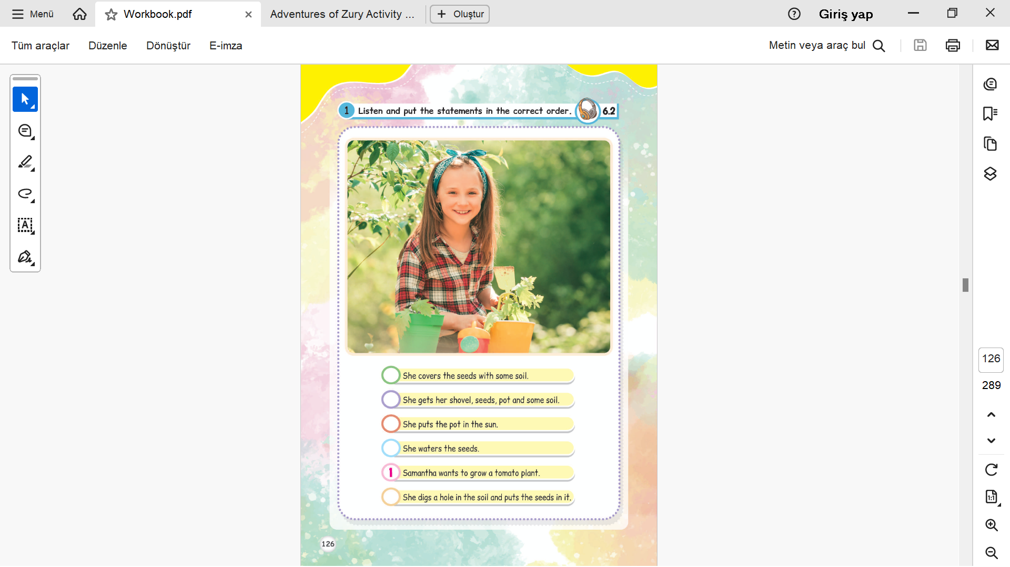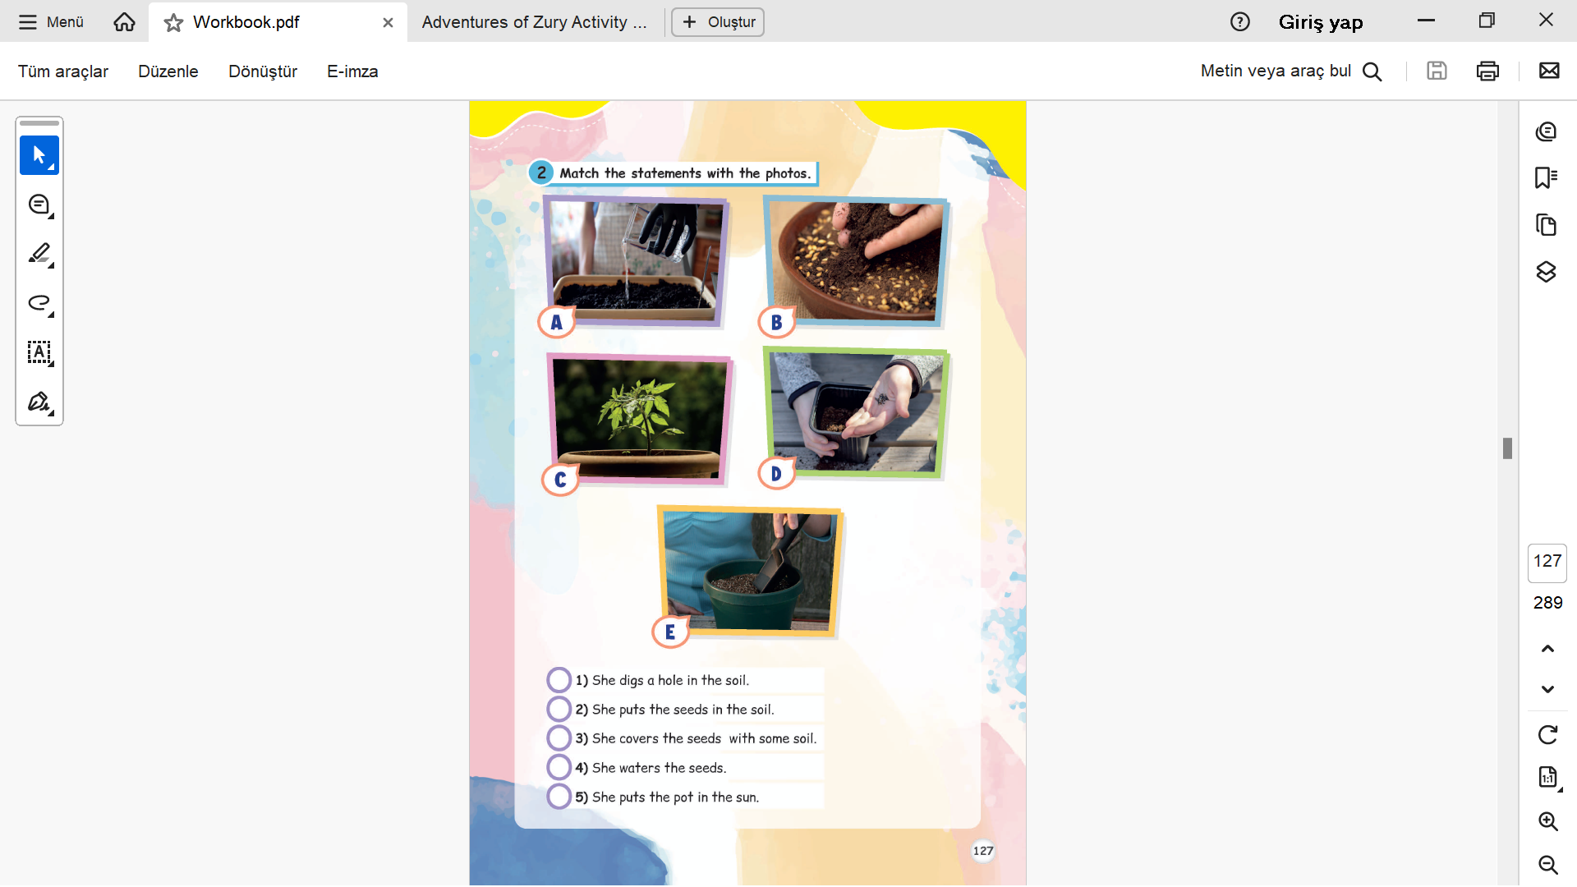

Overall, the MEB Publishing 4th-grade workbook provides a basic introduction to ecological issues, though without an interdisciplinary approach to ecological development. While there are some activities that cover ecological concepts, like planting seeds and matching related actions to pictures, the content is minimal and does not actively engage the student in a reflective consideration of ecology or sustainability.

Whereas Unit 6 includes activities like "Put the statements in the correct order" (p. 126) and "Match the statements with the photos" (p. 127), these activities, although informational, are not as likely to provide a deep understanding of ecological principles. Vocabulary presented in the units is environmentally relevant, yet without the reinforcement of accompanying songs, chants, or other interactive activities, ecological values are not as effectively transferred as they would otherwise be. The overall focus remains on teaching basic language skills without sufficiently enabling students to engage critically with the subject of ecology and sustainability.

In conclusion, while there are some elements in the MEB Publishing workbook that assist with ecological awareness, it would be strengthened by a more prominent and integrated focus on environmental concerns, along with more activities, discussions, and resources that encourage critical thinking and deeper environmental awareness.

**TEACHERS' & STUDENTS' PERSPECTIVES**

A number of challenges have been pointed out by teachers in trying to include ecological topics in English lessons. These challenges vary from insufficient appropriate teaching material specifically aimed at sustainability, to the need for more training in how to include environmental topics in the curriculum, and insufficient classroom time. Furthermore, the absence of instructions from textbook publishers on how to handle these topics in a class further works to make their inclusion more complicated. Teachers also pointed out that ecological topics may not always be aligned with the level of language or vocabulary required by the curriculum. On a few occasions, students have taken the initiative to incorporate environmental themes into their own language learning projects. These have included researching climate change, writing essays or reports on sustainability, and participating in local environmental campaigns within their community. These have been extracurricular and not a priority of their English classroom curriculum. Students remarked that while they wanted to take action, they would welcome more formal opportunities to discuss ecological issues in the classroom context.

In short, both educators and students recognize the value of incorporating environmental issues into English language instruction. However, a lack of resources, guidelines, and curriculum support currently hinders ecology from being successfully incorporated into the lessons. To reinforce environmental education in ELT, educators must be provided with the tools, training, and materials needed to address ecological issues more comprehensively.

**PUBLISHING GUIDELINES & POLICY RECOMMENDATIONS**

There are currently no official guidelines or publishers' specifications for the inclusion of environmental content in the ELT textbooks. However, it is important to recognize the growing importance of introducing environmental issues into teaching materials. Publishers are encouraged to include topics of sustainability, ecological awareness, and environmental responsibility throughout the curriculum. This could include activities, discussions, and vocabulary on nature, climate change, and conservation to foster a more environmentally conscious learning environment.

Although there are no explicit policy guidelines from the publishers in the textbooks, upcoming curricula need to prioritize the inclusion of sustainability issues. Including environmental content in ELT curricula is a significant component of the students' overall education and is recommended. The inclusion of real-world, practical examples of green issues and environmental critical thinking activities can help students make useful connections between language learning and world sustainability issues. Teachers need to demand a more active role in urging publishers to incorporate these issues in their textbooks.

By incorporating these elements, ELT textbooks can contribute more to making students more aware of environmental issues, encouraging them to practice environmentally responsible behavior and acknowledge their impact on the world.

**CONCLUSION & FUTURE DIRECTIONS**

This review illustrates significant potential for the inclusion of environmental education in English Language Teaching (ELT) curricula, as seen from the national textbook review. While some textbooks, particularly those from MEB Publishing, try to introduce ecological concepts via planting and caring for the environment activities, these efforts are restricted in scope and depth. Most units introduce fragmented vocabulary for nature, while critical thinking tasks and ecological issues of broader concern are typically absent. Moreover, tasks like songs and chants, through which environmental awareness could be raised, are also not treated appropriately.

In order to promote environmental education in ELT curricula, textbooks are suggested to incorporate more comprehensive and varied ecological content, problem-solving exercises, discussions, and real-life applications that encourage the students to think critically regarding environmental issues. Furthermore, the use of interactive activities, such as group projects on sustainability, environmental games, and cross-curricular projects, would provide a more powerful and engaging model of ecological education.

This report constitutes a component of EcoLingua’s comparative research worldwide by offering a snapshot of how environmental education is placed within ELT curricula, with a particular interest in how different educational materials deal with ecological concerns. The report will be useful for the subsequent development of digital pedagogical resources and curriculum designs in alignment with global efforts to integrate environmental awareness into language learning.

References

Cates, K. A. (2000). Environmental education in the foreign language classroom: A global perspective. *The Language Teacher, 24*(7), 19-21.

CoE (Council of Europe). (2001). *Common European Framework of Reference for Languages: Learning, Teaching, Assessment*. Cambridge University Press.

Krippendorff, K. (2018). *Content analysis: An introduction to its methodology* (4th ed.). Sage publications.

Tudor, I. (2001). *The dynamics of the language classroom.* Cambridge University Press.

Turkish Ministry of National Education. (1973). *Basic Law of National Education No. 1739*. Retrieved from <http://mevzuat.meb.gov.tr>

UNESCO. (1995). *Learning: The treasure within* - Report to UNESCO of the International Commission on Education for the Twenty-First Century. Paris: UNESCO.