NATIONAL REPORT ON ECOLOGY & CLIMATE ISSUES IN ENGLISH LANGUAGE TEACHING CURRICULA
📅 Reporting Period: 24/03/2025
✍️ Prepared by: Dr. Pelin Derinalp (C), Dr. İbrahim GİRİTLİOĞLU , Gaziantep University
📍 Country: Türkiye

Introduction
This report explores how and to what extent topics related to ecology, climate change, and environmental sustainability are incorporated into the English Language Teaching (ELT) Program published by the Turkish Ministry of National Education (MEB) in 2018. The analysis focuses on the relevant units within the curriculum for secondary school students (grades 5-8), examining at which grade levels and through which thematic components these environmental issues are addressed.

Brief overview of Turkish education system regarding English Language Teaching
In the Turkish education system, English language teaching (ELT) is based on the Common European Framework of Reference for Languages (CEFR). This framework adopts an approach that seeks to develop language learning as a real-life communicative skill and not just as a subject of study. That is, the curriculum encourages language use in an authentic communicative environment and presents English to students in a real-life context. In this regard, an eclectic approach is applied, blending different teaching methods to support the development of students' language skills.
The aim of the curriculum is to provide students with a positive attitude from the beginning of the language learning process. The curriculum emphasizes age-appropriate tasks and problem-solving skills to help students develop communicative competence. At the same time, the curriculum enables students to experience learning in a fun and motivating way. By using authentic materials such as drama, role-play and hands-on activities, students are encouraged to use English as an active means of communication.
In Türkiye, English Language education officially starts as early as the second grade of primary school as part of the curriculum. In Grades 2 and 3, the focus is mainly on speaking and listening skills, while reading and writing skills are added as students progress to more advanced levels. In secondary school, in addition to the transfer of grammar, the aim is for students to acquire the ability to use English effectively. This process treats language learning not only as the acquisition of theoretical knowledge, but also as a life skill in which students can actively use their language skills in everyday life. In this way, students are expected to become competent enough to use English not only as an academic tool but also to use it effectively in communication.
The aim of this report is to analyze how important global issues such as ecology, climate change, and environmental sustainability are addressed in the ELT curriculum at the secondary school level in Türkiye. The inclusion of these topics in the curriculum is of great importance not only for developing students' language skills but also for creating and raising the necessary awareness for a sustainable future.
This report is directly related to the objectives of the EcoLingua project. Firstly, the aim of the report is to examine the relationship between language education and environmental sustainability in the current curriculum and to assess what elements of the curriculum address both of these areas. This examination serves the EcoLingua project's aim of bridging the gap between language education and environmental sustainability. Identifying the current situation enables data-driven decisions to be made that will help the project take the necessary steps to bridge this gap. Furthermore, the report contributes to the project's goal of developing data-driven curricula by providing a data-driven approach to the curriculum development process. Finally, enhancing teachers' competencies, creating examples of good practice and promoting international teacher collaboration, through in-service trainings, course materials and other resources to be developed in line with the outputs of the report, will contribute significantly to the EcoLingua project's objectives of enhancing teacher competencies.

NATIONAL CURRICULUM OVERVIEW

Official ELT Curriculum Guidelines
As of 2024, although a new curriculum was published in Türkiye under the name “ Türkiye Yüzyılı (Century of Türkiye)”, there is no mention of the ELT program in this new curriculum. This shows that the curriculum changes implemented in 2024 did not include an update for ELT and that the 2018 curriculum remains valid for ELT at the national level.
The English curriculum in Türkiye is prepared and implemented by the Ministry of National Education (MEB). The program is aligned with the Common European Framework of Reference for Languages (CEFR) and aims to provide students with listening, speaking, reading and writing skills (Milli Eğitim Bakanlığı, 2018). The program focuses on developing language skills in real-life scenarios, providing students with the opportunity to use English as a means of communication.

Main Objectives of the English Curriculum in Türkiye
The 2018 ELT Program recognizes that the ability of Turkish citizens to communicate effectively at the international level is one of the key elements of economic, political and social development. In this context, English language proficiency plays an important role in global interaction and cooperation. The program emphasizes that language learning is not only an academic goal, but also a tool that enables individuals to communicate effectively at the international level.
The program states that for language learning to be meaningful, materials need to be directly related to students' daily lives. This approach requires language learning to be designed in a way that enables students to actively use language in real interactions, rather than merely transferring theoretical knowledge. Accordingly, the main aim of language teaching is to enable students to use English as a means of communication, and the development of language skills is not only a grammatical learning process but also takes place in a broader communicative context.

General Objectives and Learning Strategies
The curriculum determines how students will interact in the language learning process and how teachers will shape this process. Various dimensions of learning strategies are addressed and it is emphasized that teachers can select appropriate materials and tasks for students in classroom tasks and activities. Furthermore, the importance of providing positive feedback during the assessment and testing processes is emphasized.

Curriculum Overview: Themes of Ecology, Climate Change and Sustainability
An analysis of the current English curriculum at secondary school level in Türkiye reveals that the extent to which environmental themes such as ecology, climate change and sustainability are addressed varies according to grade level. In the Grade 5 syllabus, although there is no theme that directly focuses on these issues, it is seen that some words related to environment and climate are included in various units. In the 6th grade curriculum, in turn, these themes are covered in the 9th unit under the title “Saving the Planet”, while in the 7th grade they are covered in the 9th unit under the theme “Environment” and in the 8th grade in the 10th unit under the theme “Natural Forces”. This shows that the curriculum not only focuses on the key academic objectives of developing language skills, but also has the potential to raise environmental awareness in students.
When the curriculum is analyzed, it can be said that the emphasis in the curriculum on raising awareness about the environment and global issues is not sufficient. Addressing such themes at earlier grade levels would be a critical step in terms of raising environmental awareness. Indeed, the importance of raising environmental awareness at an early age has been recognized internationally since the 1980s, with the Tbilisi Declaration (UNESCO, 1980) emphasizing that environmental sensitivity should be developed from an early age, especially towards the learner's own community. In this context, it may be useful to integrate environmental themes into the curriculum at an earlier age and with an interdisciplinary approach. Thus, students' sustainability awareness can be shaped from an early stage and their attitudes towards these issues can develop more positively in the long run. This will contribute to raising more conscious and responsible individuals in the future.

ANALYSIS OF TEACHING MATERIALS & TEXTBOOKS
At each level, there are two textbooks approved by MEB. One is provided by MEB and the other is provided by private publishers. In addition to those, in Grade 8, there is also a supplementary material prepared by MEB Publications The analysis of these books in the context of environment and sustainability is presented below.

An Overview of Grade 5 English Textbooks
The Grade 5 English curriculum in Türkiye is offered with two different textbooks based on the syllabus published by MEB. These books are published by Pasifik Publications (Birincioglu-Kaldar, 2024) and MEB Publications (Akseki, Kurt & Pangal, 2024). These textbooks were developed in accordance with the MEB English Language Teaching Program published in 2018 and both textbooks have the same unit titles (See Table 1).

Table 1.
Content of the 5th grade English books
Pasifik Publications | MEB Publications
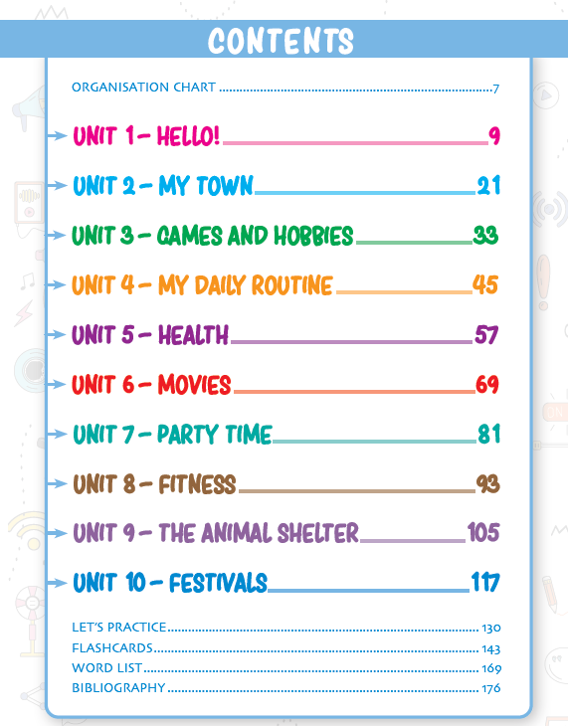 | 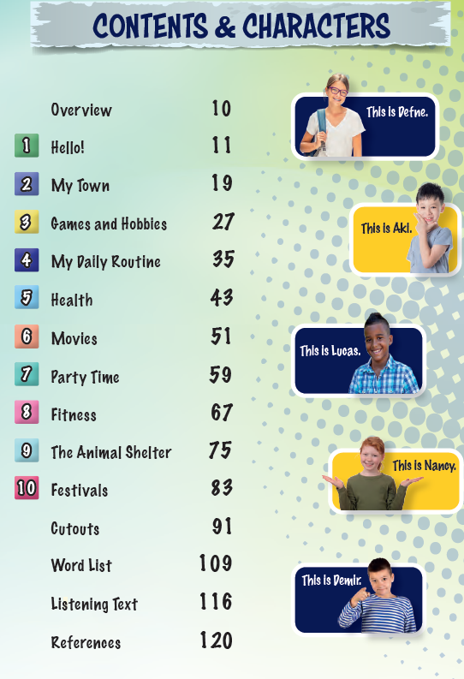
In this report, MEB’s and Pasifik Publications’ textbooks were evaluated through qualitative content analysis in the context of environmental education (EE) and education for sustainable development (ESD). Content analysis is a qualitative research method for systematically examining the presence of specific themes, concepts and words in written materials (Krippendorff, 2018).
In this regard, the content of the books was analyzed under three main categories. First, the units, sections, and topics that directly included environmental and sustainability themes were analyzed to determine the extent to which these topics were integrated into the textbooks. Second, sample texts, dialogues, reading passages and exercises were analyzed to assess how environmental issues are presented and whether they encourage active engagement with sustainability concepts. Finally, the analysis focused on green vocabulary and the use of environmental concepts to assess the depth of language exposure related to sustainability and ecological awareness. The results of the analysis are presented below in Table 2.

Table 2.
Analysis of the 5th Grade Textbooks
Criteria | MEB Publications | Pasifik Publications
Unit/ Sections /Topic on Environment and Sustainability | “Eco-friendly hobbies” (p. 27) | There are no specific units or topics directly related to the environment.
Sample Texts, Dialogues, Reading Texts and Exercises | "He likes/loves fishing, hiking, and camping." (p. 29),  “Do you like camping?” (p. 30),  “What are your eco-friendly hobbies? Make a word cloud infographic for your eco-friendly hobbies. My favorite eco-friendly hobby is cycling. I also love  gardening, hiking, and recycling things. I collect cans  and plant flowers in them. And on weekends, I go to  the beach to clean up the environment. Find out your eco-friendly hobbies (p. 34)”.  “1. Do you like being in nature?  2. What outdoor sports can you do?  3. What are your favorite outdoor  activities?” (p. 68)  “Let’s go hiking! How about jogging? How about going trekking? Let’s go cycling.” (p. 73) | There is no specific dialogue or text on environment and sustainability.
Green Vocabulary Coverage | Climbing, camping, experiments (p. 31), cycling (p. 32, 68), hiking, camping (p. 68) | In Unit 3, under the theme of Games and Hobbies, and in Unit 9, under the theme of Fitness,activities such as 'cycling' and 'hiking' (p. 34, 94) are mentioned, but they are not directly emphasized in the context of sustainability education and therefore cannot be considered in this context.
Overall Evaluation | It offers richer content on environmental awareness. Includes exercises on recycling, eco-friendly activities and environmental protection. | Environment and sustainability issues are not included. It focuses more on daily conversation and basic language skills.
The results of the comparative analysis revealed that the analyzed textbooks showed significant differences in terms of the level of coverage of environmental and sustainability issues. While the MEB textbook has explicit activities for students related to environmental sustainability, the Pasifik textbook does not directly address these issues. This can be considered as an important difference in terms of the role of the content of textbooks in creating environmental awareness in educational programs. Sterling (2001) argues that environmental education entails much more than merely imparting environmental knowledge. According to Sterling (2001), environmental education aims to enable students to approach environmental problems in a sensitive and solution-oriented manner and to develop a perspective that will raise their awareness about sustainability. In this context, the environmentally friendly activities presented in the MEB textbook show how environmental education can be concretized in the school curriculum by demonstrating a direct, albeit limited, approach to raising environmental awareness in students.
On the other hand, the absence of direct environmental content in the Pasifik textbook suggests that there are deficiencies in integrating environmental awareness into educational processes. This deficiency contradicts research suggesting that textbooks can be an important tool for environmental awareness (Zahoor & Janjua, 2019). The inclusion of environmental education in EFL course materials plays a critical role in facilitating students' development of ecological literacy (Mliless & Larouz, 2018). UNESCO-UNEP (1995) also emphasized that environmental education needs to be integrated into the whole education system and that it is important to equip individuals with the knowledge, values and skills to address environmental issues. Considering that language teaching materials should not only develop language skills but also increase ecological awareness (Mliless & Larouz, 2018; Zahoor & Janjua, 2019), the lack of environmental content in this textbook is not compatible with a sustainable education approach.
A more in-depth analysis reveals that in the MEB textbook, environmentally friendly concepts are addressed only in reading and writing skills. Within the scope of reading skills, an informative text is presented for students to explore eco-friendly hobbies (p. 27). There are also reading activities that encourage students to think about nature-related activities. In these activities, activities such as hiking and camping in nature are discussed (p. 29-30), and the task of creating a word cloud infographic highlighting environmentally friendly hobbies enables students to visualize these concepts (p. 34). Writing activities that support reading activities allow students to express their personal views about nature in writing (p. 68, 73). However, the fact that eco-friendly practices are addressed only through specific activities does not indicate that sustainability and environmental awareness are covered in a holistic manner. Evaluating the textbook in terms of its potential for developing ecological literacy requires examining the extent to which environmental education is presented in depth and systematically.

An Overview of Grade 6 English Textbooks and supplementary materials
The 6th grade textbooks approved by the MEB are provided by two different publishing houses, as in the 5th grade level: HECCE Publications (Arda & Onay, 2023) and MEB Publications (Demircan et al., 2019). These textbooks are required to be prepared in accordance with the curriculum and syllabus determined by the MEB. Therefore, the titles of the units are the same in both textbooks (See Table 3).
Table 3.
Content of the 6th grade English books
HECCE Publications | MEB Publications
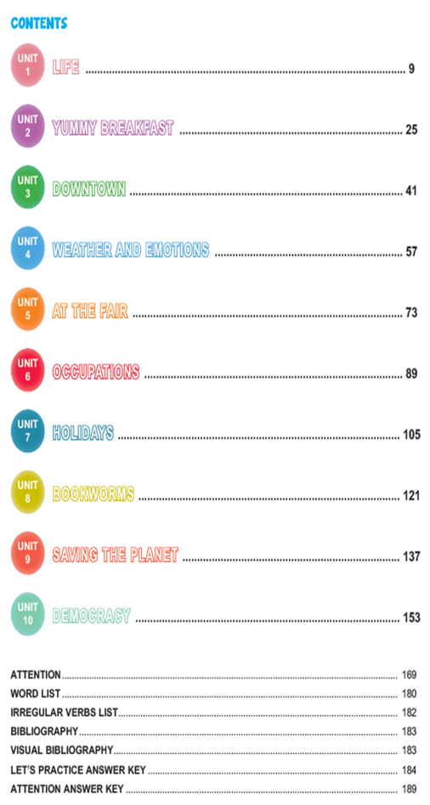 | 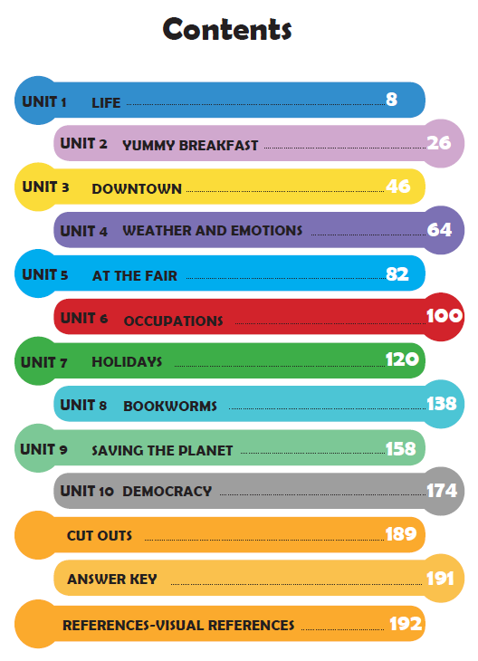

An analysis of the English curriculum and textbooks at the secondary school level in Türkiye reveals that there are differences in the way environment and sustainability issues are addressed according to grade level. The content of 6th grade textbooks reveals that Unit 9 under the theme of “Saving the Planet” is specifically devoted to environment and sustainability issues. This stands out as an important difference when compared to the 5th grade textbooks. This is because while this topic is addressed only with limited references in certain units at the 5th grade level, it is included as an independent unit in the 6th grade curriculum.
As in the 5th grade, the 6th grade textbooks were also analyzed by qualitative content analysis method according to predetermined criteria in terms of environment and sustainability and the results obtained are presented in the table below (See Table 4).
Table 4.
Analysis of the 6th Grade Textbooks
Criteria | HECCE Publications | MEB
Unit/ Sections /Topic on Environment and Sustainability | Unit 4 Weather and Emotions  Unit 9 Saving the Planet | Unit 9 Saving the Planet
Sample Texts, Dialogues, Reading Texts and Exercises | “Hi from the North Pole. I am a polar bear. I like freezing weather. I feel happy and energetic in cold weather. I like swimming in icy water. My favorite season is winter. I can’t live  in hot weather. Please stop the global warming. (p. 66)”, “There is no Planet B (p. 137)”,  “Be careful how long you take a shower  Use less water and electricity  Reducing energy is really cool  Unplug the TV when you are not using it  Turn off the computer every now and then  Throw away litter, pick up trash  And save the Earth! (p. 138)” | “Do you put things into the recycling bin? Why? Which materials can we recycle?” (p. 158).  “TIP CORNER  What should we do to save our world?  - We should use less water and electricity.  - We shouldn’t harm animals.  - We should recycle paper, glass and plastic.  - We shouldn’t waste energy.  - We should unplug the TV.  - We should use wind and solar energy.” (p. 162)
Green Vocabulary Coverage | Global warming (p. 66), Reuse, Reduce, Recycle, Go Green (p. 138), biodegrade (p. 139), not waste food, take care of their environment (p. 162). | Recycle our litter, use public transportation, cycle or walk, protect our environment (p. 162), reduce air pollution, use environmentally friendly products (p. 163)
Overall Evaluation | In the textbook, sustainability principles are introduced in order to raise environmental awareness. The unit “Saving the Planet” focuses on water efficiency, recycling and energy use, while the unit “Weather and Emotions” draws attention to global warming. | The MEB textbook also encourages eco-friendly habits, but lacks in-depth discussion of environmental issues.
Both textbooks aim to promote eco-friendly habits and focus on sustainability issues in the unit titled “Saving the Planet”. The HECCE textbook covers various subtopics related to environmental issues and introduces students to basic sustainability principles such as saving water, recycling, reducing plastic use. In addition, the suggestions that form the basis of the teaching focus on students adopting environmentally friendly behaviors in their daily lives. For example, to prevent wasting water, “Turn the Tap off While Brushing!” (p. 140). Apart from the “Saving the Planet” unit of the HECCE textbook, the only example of environmental awareness is in the “Weather and Emotions” unit. In this unit, a polar bear utters the following statement: “Hi from the North Pole. I am a polar bear. I like freezing weather. I feel happy and energetic in cold weather. I like swimming in icy water. My favorite season is winter. I can’t live in hot weather. Please stop the global warming (Arda & Onay, 2023, p. 66)”. This statement expresses the polar bear's concern about global warming and is followed by a fill in the blanks activity based on it. However, although weather and emotions are covered together in the “Weather and Emotions” unit, in-depth topics such as the broader effects of global warming and its emotional repercussions on humans, nature or animals are not addressed. At this point, a more detailed discussion of the effects of global warming, especially discussions about its emotional dimensions, could have increased students' awareness of the subject. Yet, it is noteworthy to state that there are no detailed discussions on the environment and sustainability in the MEB textbook, except for the Saving the Plante unit.
The MEB textbook, on the other hand, includes content based on the theme of sustainability, such as energy saving, recycling, water use and protection of natural resources. The emphasis here is similarly on the acquisition of eco-friendly habits. To illustrate, the dialogues between Ali and his family aim to instill in students an awareness of energy conservation, but do not include in-depth discussions on environmental issues.
As for vocabulary and concepts, the green vocabulary used in both textbooks is generally at the beginner level. Concepts such as “reuse”, “reduce”, “recycle” are introduced to students, but these terms are usually presented at a more superficial level. Concepts such as “carbon footprint” and “renewable energy” are not included. This may prevent students from understanding environmental awareness in a broader context.
The HECCE textbook introduces the principles of sustainability, aiming to raise environmental awareness. In the “Saving the Planet” unit, issues such as water efficiency, recycling and energy use are addressed. Moreover, differently from the MEB textbook, the Weather and Emotions unit draws attention to environmental problems such as global warming. The MEB textbook also encourages eco-friendly habits. Issues such as recycling, energy saving and water use are mentioned, but a more comprehensive discussion of environmental issues is missing. Nevertheless, it helps students develop environmentally conscious habits.

An Overview of Grade 7 English Textbooks
The 7th grade English curriculum in Türkiye is offered through two different textbooks based on the 2018 English Language Teaching Program determined by the MEB: Yıldırım Publications (Cenk & Gezmiş, 2024) and MEB Publications (Çatlı et al., 2024). Both books were developed in accordance with this program, including the same unit titles. As in the 5th and 6th grade textbooks, the 7th grade textbooks were also analyzed with the qualitative content analysis method according to predetermined criteria in terms of environment and sustainability and the findings are displayed in the table below (See Table 5).
Table 5.
Analysis of the 7th Grade Textbooks
Criteria | Yıldırım Publications | MEB Publications
Unit/ Sections /Topic on Environment and Sustainability | Unit 4 Wild Animals,  Unit 7 Dreams,  Unit 9 Enviroment | Unit 4 Wild Animals,  Unit 9 Enviroment
Sample Texts, Dialogues, Reading Texts and Exercises | “People shouldn’t harm animals’ habitat (p. 54).”,  “Are you environmentally friendly?  1. Do you have a long shower?  2. Do you often use perfume?  3. Do you use only one side of a paper?  4. Do you leave the lights on when you don’t use?  5. Do you use plastic shopping bags?  6. Do you throw rubbish on the street?  7. Do you harm animals? (p. 108).” | “What should we do to protect the wild life? (p. 55)”,  “Write some suggestions to protect them (p. 60)”.  “Do you have recycle bins at your school? What can you do to save electric energy? (p. 108)”  “Ecology is very important for all living beings. People have a big effect on ecosystem. Their wrong habits cause pollution, climate change, deforestation and extinction of animals. All these come together and the Earth faces global warming. Global warming is very dangerous because the Earth is getting warmer (p. 109).”
Green Vocabulary Coverage | Endangered and extinct animals, pollution, (p. 53), water shortage, climate change, hunger, cars running with water (p. 88), pollution (p. 92, 93),waste of water, extinction, pollution, drought, pesticides (p. 108) | use eco-friendly products, protect their habitat, plant trees (p. 55), renewable resources, air pollution, recycle bins (p. 109)
Overall Evaluation | Compared to the MEB textbook more environmental terms are presented in this textbook. | The MEB textbook includes more practical suggestions compared to Yıldırım textbook.
Grade 7 English textbooks, similar to Grade 6 textbooks, include the themes of environment and sustainability. In the curriculum determined by MEB, the “Environment” and “Wild Animals” units are directly related to these topics. However, when the content analysis of the books is analyzed, it is seen that the emphasis on the environment differs according to the publishing house.
Upon a closer examination of the textbooks prepared by MEB and Yıldırım Publications, it was found that Yıldırım Publications covered environmental and sustainability issues more. While environmental issues are limited to certain units in the curriculum published by MEB, Yıldırım Publications not only covers this topic in the “Environment” and “Wild Animals” units, but also in the “Dreams” chapter. Both books aim to raise students' awareness of the environment and sustainability. However, Yıldırım Publications emphasizes more on environmental issues, whereas, in the MEB book, these contents are limited to certain chapters. In order to provide students with more comprehensive environmental awareness, it may be useful to include more of these topics in different units.

An Overview of Grade 8 English Textbooks
The 8th grade English textbooks, as in the other levels, were prepared based on the 2018 English Language Teaching Program determined by MEB and are offered through two different sources: Bilim ve Kültür Publications (Tan, 2024) and MEB Publications (İlter et al., 2022). Both textbooks were developed to include the same unit titles in accordance with the program (See Table 6).

Table 6.
Content of the 8th grade English books
Bilim ve Kültür Publications | MEB Publications
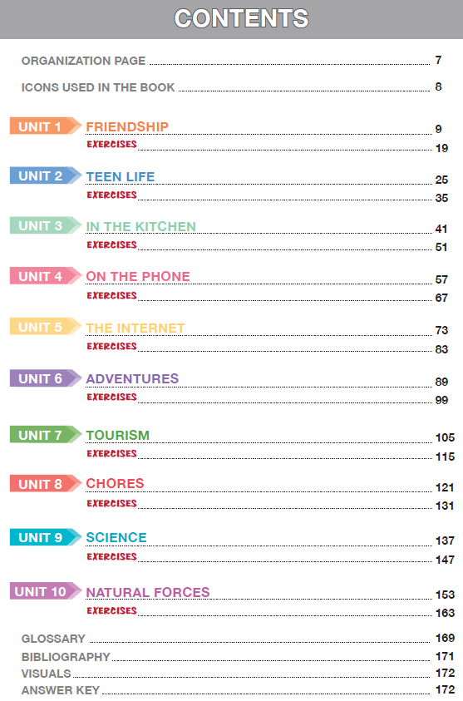 | 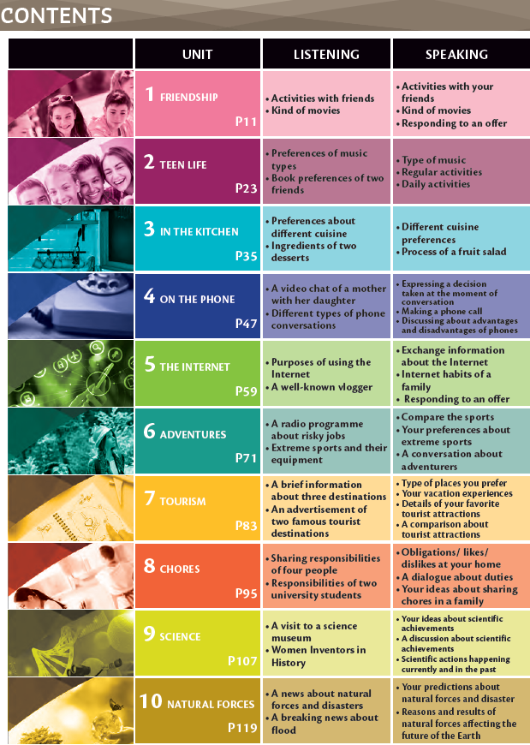
Upon a closer examination of the table of contents of Bilim ve Kültür Publications, it is observed that the book consists of 10 main units and each unit is followed by related exercises. The thematic distribution of the units is as follows: “Friendship”, “Teen Life”, “In the Kitchen”, “On the Phone”, “The Internet”, “Adventures”, “Tourism”, “Chores”, “Science” and “Natural Forces”. The book presents the units only at the title level and does not include detailed information about the content.
On the other hand, in the English textbook prepared by MEB Publications, the units are organized under 10 main headings and same themes are covered. However, in this publication, not only the title of each unit is indicated, but also how it is supported by listening and speaking activities. In the table of contents section of the book, the skills that each unit focuses on are explained in detail. For example, in the “Natural Forces” unit, listening activities include learning about natural forces and listening to news reports about them. In the speaking section, it is stated that skills such as making discussions on natural disasters and their effects, evaluating the measures that can be taken against disasters and exchanging ideas on these issues are developed.
In line with this comparison, it can be said that the content of Bilim ve Kültür Publications' book is presented in a more general framework, whereas MEB Publications' book provides detailed information on how each unit is associated with language skills. While the MEB textbook deals with the language teaching process in a structured way, the Bilim ve Kültür Publishing book presents a structure that lists topics and exercises. This reveals that the MEB book is more of a guide in the teaching process and shows more clearly how to achieve certain outcomes for teachers and students.
Following the other levels, Grade 8 textbooks were analyzed in terms of environment and sustainability according to predetermined criteria using qualitative content analysis method and the findings are shown in the table below (See Table 7).
Table 7.
Analysis of the 8th Grade Textbooks
Criteria | Bilim ve Kültür Publications | MEB Publications
Unit/ Sections /Topic on Environment and Sustainability | Unit 10 Natural Forces | Unit 7 Tourism  Unit 10 Natural Forces
Sample Texts, Dialogues, Reading Texts and Exercises | “1. Scientists are extremely interested in climate changes.  2. Our planet isn't warming up.  3. Droughts, avalanches, floods and so on are all ecological disasters.”, “…We should stop wasting water sources…”, “I think we'll have water shortages in the future because we waste too much water. I guess we should take serious precautions (p. 155).” | “Firstly, our tour guide informed us about the place, ecosystem and the wild life of the National Park (p. 91).”, “safer enviroment, cheaper energy resourse! (p. 114)”, “I think there’ll be erosion because we destroy forests. So many animals and plants will extinct in the future (p. 120).”
Green Vocabulary Coverage | Global warming (p. 155), climate change (p. 157), earthquake, drought, landslide, tsunami, hurricane, tornado, avalanche, water shortage (p. 161), wildfires, forest degradation, air pollution, destruction of watersheds, ecosytem (p. 162) | Solar panel system (p. 114), drought, hurricane, earthquake, tsunami, landslide, volcano (p. 120), global warming, melting of glaciers, extinction, climate (p. 121), deforestation (p. 123), eco-friendly, recycle, recharchable batteries, renewable energy (p. 125)
Overall Evaluation | The textbook contains more scientific information than the MEB Publications' textbook, but does not provide a sufficiently comprehensive framework from a sustainability perspective. | The textbook devotes more space to environmental issues than the Bilim ve Kültür Publications' textbook, providing students with the opportunity to generate solutions.
In both books, the units that directly or indirectly address environment and sustainability issues were identified and analyzed. It is seen that both books address environmental issues such as natural disasters, especially in Unit 10: Natural Forces, as per the curriculum published by MEB. Apart from this, there are sections in different units that indirectly touch upon the concept of sustainability. However, it was found that the direct coverage of these issues was limited. For example, in the textbook of Bilim ve Kültür Publications, the word safari is mentioned only once in the context of tourist attraction. This usage does not include a direct environmental or ecological emphasis and is presented only as a touristic activity. On the other hand, in the textbook of MEB Publications, the word safari is used only once in the context of tourist attraction. On the other hand, in the textbook of MEB Publications, the word safari is mentioned once again. However, in this context, it is not only presented as a touristic activity, but also as a trip to a national park and associated with elements such as the ecosystem and wild nature there.
Overall, The coverage of environmental issues in the MEB textbook is broader than in the Bilim Kültür Publishing textbook. The book offers students a solution-oriented approach and aims to raise awareness about environmental problems. For example, the chapters on natural forces provide information on measures that can be taken at the individual and societal level. In addition, while addressing the effects of natural disasters on the ecosystem, suggestions for the protection of nature are presented. On the other hand, the Bilim Kültür Publications' book adopts a more scientific perspective. While explaining environmental concepts, academic language is used and cause-effect relationships of natural phenomena are emphasized. However, it is seen that the activities and solution suggestions that will provide students with an active role in the context of sustainability are limited. It can be concluded that although both books provide important content to develop environmental awareness, the MEB book allocates more space to environmental issues and gives students the opportunity to produce solutions. In order to provide more detailed and multidimensional coverage of environmental and sustainability issues, it is recommended that both books be supplemented with additional materials emphasizing individual and social responsibilities.
It is worth noting that MEB published an English textbook as a supplementary material in 2022 (Demircan et al., 2022), and it was observed that the environment and sustainability issues were covered in this material within the scope of the Natural Forces unit as per the MEB's curriculum. It was also revealed that the vocabulary and activities in this supplementary material were very similar to the content of the textbook published by the MEB.

TEACHERS' PERSPECTIVES
In addition to analyzing the textbooks, focus group discussions with teachers were conducted to gain insights into their views, students' approaches and other relevant factors. In this regard, a total of two focus group discussions (FGDs) were conducted with two secondary school English teachers. The total duration of the interviews was 43 minutes and the second interview was repeated one week later at the request of the participating teachers. In this second FGD, which lasted only 3 minutes and 41 seconds, the teachers reflected on the positive impact of the first session on them and how it contributed to raising their awareness. During the first FGD, teachers were asked about the position of environmental and sustainability issues in the curriculum, their own approaches to these issues and the challenges they face, and the importance students attach to these issues. The transcribed data were analyzed using Clarke and Braun's (2006) six-stage thematic analysis method. The findings are presented below under four main themes.
Position of Environment and Sustainability in the EFL Curriculum
Teachers reported that environmental and sustainability issues are included in the curriculum, but the content is limited. In particular, it was stated that there are certain units related to these topics in the 6th, 7th and 8th grade curriculum, while it was emphasized that there is no content at the 5th grade level. This finding is consistent with the textbook analysis. In addition, it was stated that environmental units are usually placed at the end of the curriculum and therefore the subject is not covered sufficiently due to reasons such as increased absenteeism rates at the end of the school year and decreased motivation of students.
Another point that the teachers noted was that although environmental issues are included in the textbooks, the content remains limited to specific grammar structures, such as "should" and "shouldn't," rather than fostering deeper critical thinking or active engagement. T1, for example, explained that in both sixth and seventh grades, she integrated environmental topics through the grammatical structures of “should” and “should not” by having students create posters about what to do or not to do for the environment. However, she emphasized that these activities stayed within the boundaries of the curriculum and did not leave much room for flexibility or creativity.
Teachers' Approach and Challenges
Teachers expressed a willingness to integrate environmental and sustainability issues into their lessons yet were unable to address these issues in depth due to the structural and practical limitations imposed by the curriculum. They feel that they do not have enough autonomy to deviate from the curriculum. For example, T1, who works in a disadvantaged area, stated that although she would like to provide more hands-on learning opportunities for students, the current conditions pose a challenge in providing such opportunities. So, she admitted that she mostly follows the textbook.
It was also mentioned that the infrastructural facilities of schools hinder the effective teaching of environmental and sustainability issues. T2 explained that the technological inadequacies in the school complicate the teaching process as follows: “There is only one smart board in our school and it is reserved for 8th graders. I have to constantly change classes in order to do activities with 5th graders, so we cannot even use the interactive content on EBA (which is an online platfrom supported by MEB).” (FGD1, T2). These statements suggest that teachers are unable to teach important topics such as environmental sustainability more effectively due to limited resources and lack of infrastructure.
Inadequate awareness of teachers on environment and sustainability issues, lack of adequate professional development opportunities in this field and lack of relevant trainings are among the main challenges faced by teachers. As a result of the first FGD, it was observed that teachers' awareness of environmental awareness increased. As a matter of fact, one week after the first FGD, T1 reported that she screened a video on the harms of plastic bottles and carried a glass water bottle to the classroom every day to be a role model in order to raise environmental protection awareness in her students. She stated that as a result of this action, she observed behavioral changes in some of her students. In addition, T2 stated that she initiated a project to plant trees in the school garden in consultation with the school administration. Moreover, T2 stated that although the “future tense” topic in the 7 graders’ textbook is focused on robots and artificial intelligence, she took the initiative and preferred to address this topic from the perspective of environment and sustainability. In this context, she asked the students “What do you think will happen in the future in the world around us?” and prompted them to think about environmental changes. This approach increased teachers' environmental awareness and reinforced their motivation to teach environmental sustainability in their lessons. As a result, it can be said that increasing teachers' environmental awareness not only improves the quality of their teaching processes, but also paves the way for a more effective educational process that improves students' environmental awareness.
Students' Commitment to Environment and Sustainability Issues
It was found that students' level of awareness of environmental issues was largely related to their family structure and socio-economic background. While some students were observed to be environmentally conscious and actively participate in practices such as recycling, other students were reported to be indifferent to the environment and lacked awareness of environmental protection. For example, T2 stated that “Some of my students ask, ‘Teacher, can I recycle the paper?’ and even compete with each other,” (FGD1, T2) while T1 said, “My students do not hesitate to waste soap in vain.” (FGD1, T1). The participant teachers explained this situation by the visible positioning of recycling bins in T2's school and the role modeling of teachers and school administrators, while in T1's case, the general environmental insensitivity of the family and environment was observed to be effective.
Another finding is that students' interest levels are generally directed towards topics that are concrete and can be associated with daily life. T2 explained this situation as follows:
Abstract topics such as global warming are not very understandable for students. But when we give concrete examples such as endangered animals, especially female students show a lot of interest. For example, my students were very upset when they learned that pandas are endangered (FGD1, T2).
Teachers also emphasized that students showed more interest in projects and that such activities could increase students' motivation. T2 explained how her students enthusiastically participated in an environmental project as follows: “My students and I made crackers for birds and hung them on trees. They looked forward to the project day and even wanted to show and tell their other teachers” (FGD1, T2).
Hence, it can be said that students' environmental awareness is directly related to their family background and socio-economic status. It was observed that they showed more interest in concrete environmental problems and projects, and less interest in abstract concepts. Teachers' raising students' awareness by associating environmental issues with concrete examples and including them in projects emerges as an effective method in developing environmental awareness. These findings emphasize the importance of teachers' role modeling and participatory methods in environmental education.
Suggestions and Directions for Improvement
Teachers offered various suggestions to enhance the effectiveness of environmental and sustainability education. It was stated that the content of the curriculum needs to be revised and that it would be more beneficial to address environmental issues earlier in the year rather than in the last units of the year. T2 expressed her suggestion on this issue as follows: “Students would be more interested if we could cover environmental issues in earlier units rather than at the end of the year. When it is left to the end of the year, students get overwhelmed and distracted” (FGD1, T2). Suggestions to increase students' active participation include project-based learning, organizing sustainability activities in the school garden, and enriching textbooks with authentic materials. T1 stated that incentive systems for students could be useful and offered the following suggestion by expressing “If a reward system such as 'the most environmentally friendly student' is established at school, students may become more sensitive to environmental issues” (FGD1, T1). Teachers also stated that professional development programs need to include environmental education topics. They stated that they lack such trainings. Finally, teachers emphasized that environmental issues need to be addressed not only at school, but also at home and in daily life to create a sustainable consciousness. Both families and school administrations should play a more active role in developing students' environmental habits.
CONCLUSION & FUTURE DIRECTIONS

This report examines how the themes of environment and sustainability are addressed in the secondary school English curriculum. First, the overall structure of the curriculum is evaluated, then textbooks are analyzed to determine the extent to which environmental themes are integrated into the curriculum. Finally, through focus group discussions with teachers, insights into the classroom practices of these themes and their reflections on students were obtained.

The curriculum aims to promote language use in a theoretically authentic communicative environment, enabling students to learn English in a real-life context and develop their communicative competence. To this end, an eclectic teaching approach is adopted, emphasizing age-appropriate tasks and problem-solving skills. In addition, the use of authentic materials such as drama, role-playing and hands-on activities is recommended to help students develop a positive attitude towards learning English. However, when the textbooks are analyzed and teachers' experiences are collected, it is seen that this vision presented by the curriculum is not fully implemented in the classroom.
In particular, the activities in the textbooks do not fully coincide with the objectives of the curriculum. While the 5th grade textbooks do not include environment and sustainability issues at all, the 6th, 7th and 8th grade textbooks only cover them in one unit each. Moreover, since these units are usually placed at the end of the curriculum, they are not adequately addressed due to absences at the end of the year, intense exam preparations and loss of motivation. Although it is important to address these themes at an early age in order for students to develop an awareness of the subject, it is found out that the current structure does not support this.
In addition, the authentic and interactive learning environments envisaged in the curriculum are not fully reflected in actual classroom practice. Teachers reported that they do not have enough time and flexibility to implement the methods outlined in the curriculum. Moreover, the interviews indicate that many teachers do not receive adequate guidance on how to integrate environmental and sustainability issues into English language teaching. Although the curriculum theoretically encourages activities that motivate students and focus on communication, there is no concrete guidance on how teachers can implement these activities. As a result, some teachers try to fill this gap by developing projects through their individual efforts, while others are limited to simple activities due to the demanding curriculum.
In conclusion, while the pedagogical framework offered by the curriculum has a strong potential for environmental and sustainability education, it faces several obstacles in practice. The content of textbooks, the level of support for teachers and the density of the curriculum make it difficult to effectively realize the set objectives in the classroom. Therefore, there is a need to organize professional development programs for teachers, enrich textbooks with more authentic and interactive activities, and move environmental themes earlier and more centrally in the curriculum.

References
Akseki, Ö., Kurt, Ö., & Pangal, O. (2024). Move up 5th grade student’s book. Milli Eğitim Bakanlığı Yayınları.
Arda, A., & Onay, Ö. (2023). Sunshine English 6: Ders kitabı. Hecce Yayıncılık.
Birincioğlu Kaldar, E. (2024). English student’s book: 5th grade. Pasifik Yayınları.
Braun, V., & Clarke, V. (2006). Using thematic analysis in psychology. Qualitative research in psychology, 3(2), 77-101.
Cenk, P. & Gezmiş, N., (2024) English 7. Yıldırım Yayınları.
Çatlı, E., Çepik, G., Çevik, S. & Ünlü, A. G. (2024). English Grade 7 Coursebook. Milli Eğitim Bakanlığı Yayınları.
Demircan, F., Akıskalı, G., Berket, A., & Günay, F. (2019). Ortaokul ve İmam Hatip Ortaokulu İngilizce 6 ders kitabı. Milli Eğitim Bakanlığı Yayınları.
Demircan, F., Akıskalı, G., Berket, A., & Günay, F. (2022). Ortaokul İngilizce 8 çalışma kitabı. Milli Eğitim Bakanlığı Yayınları.
İlter, B., İzgi, İ., Çavuşer-Özdemir, E., Türkeri-Yeter, A. & Çavuşer-Yünlü, Z., T. (2022). Mastermind Ortaokul ve İmam hatip Ortaokulu İngilizce 8 Ders Kitabı. Milli Eğitim Bakanlığı Yayınları.
Krippendorff, K. (2018). Content analysis: An introduction to its methodology. Sage publications.
Millî Eğitim Bakanlığı. (2018). İngilizce dersi öğretim programı (İlkokul ve Ortaokul 2, 3, 4, 5, 6, 7 ve 8. sınıflar). Millî Eğitim Bakanlığı.
Mliless, M., & Larouz, M. (2018). An ecolinguistic analysis of environment texts in Moroccan English language teaching textbooks. International Journal of Research in Environmental Studies, 5, 103-116
Tan, F. (2024). English Grade 8. Bilim ve Kültür Yayınları.
UNESCO. (1980). Environmental education in the light of the Tbilisi conference. UNESCO.
UNESCO-UNEP (1995). Two decades of successful interagency cooperation for the worldwide promotion of environmental education. Connect: UNESCO-UNEP Environmental Education Newsletter. Vol. XX, no, 3.
Zahoor, M., & Janjua, F. (2020). Green contents in English language textbooks in Pakistan: An ecolinguistic and ecopedagogical appraisal. British Educational Research Journal, 46(2), 321–338. https://doi.org/10.1002/berj.3579

